FUN GAMES

Software Design Specification

Version:1

Date Created: 2015.03.23

|  |  |  |
| --- | --- | --- |
| Date | Revision | Approved By |
| 23.03.2015 | Version 1.0 | Prof. Lydia Jane G |
|  |  |  |

Signatures

|  |  |  |
| --- | --- | --- |
|  |  |  |

List of contributors

|  |  |  |  |  |
| --- | --- | --- | --- | --- |
| Name |  | Registration no |  | Email |
| Baijayanti Chakraborty |  | 12BCE0105 |  | aparnachakraborty7542@yahoo.in |
| Mitu |  | 12BCE0552 |  | mitudubey97@gmail.co |
| Vikhyati Singh |  | 12BCE0603 |  | vikhyati0855@gmail.com |

Change History

|  |  |  |  |  |
| --- | --- | --- | --- | --- |
| Revision |  | Date |  | Description |
|  |  |  |  |  |
|  |  |  |  |  |
|  |  |  |  |  |

**Preface**

This document presents the Software Design Specification for the fun games (who am I ? and tic tac toe) project . The major sections of the document address the system decomposition by

module, concurrent process, and data entity. The system dependencies are also described.

Section 2, Decomposition Description, gives a view of the whole system design including

concurrent processes and data entities that are common amongst all system modules. An

important discussion of how the who am I selecting celebrities modules can be entertained by software is included this section. This discussion includes a UML Class Diagram that depicts the

entire system.

Section 4, Interface Description, goes into detail about the user interface for each module of the

Who am I ? and Tic-Tac-Toe . This is followed by an important discussion of the processes implemented in logic for each module of the system.

Section 5, Detailed Design, extends the design discussion found in Section 2 and describes the

design for each system module in more detail. A UML Class diagram is included for each module

design discussion. This is followed by a description of the data requirements for each module

and the design of those data elements.

**Table of Contents**

**1. INTRODUCTION ………………………………………………………………………………………………6**

1.1 Purpose ……………………………………………………………………………….6

1.2 Scope……………………………………………………………………………. ……6

1.3 Definitions and Acronyms …………………………………………………………...6

1.4 References ……………………………………………………………………………6

**2.SYSTEM OVERVIEW …………………………………………………………………………………………7**

**3.SYSTEM ARCHITECTURE …………………………………………………………………………………..8**

3.1 Architectural Design …………………………………………………………………8

3.2 Decomposition Description………………………………………………………….8

3.3 Design Rationale…………………………………………………………………….10

3.4 Design Issues………………………………………………………………………...11

**4. DATA DESIGN……………………………………………………………………………………………….12**

4.1 Data Description……………………………………………………………………. .12

**5. COMPONENT DESIGN……………………………………………………………………………………..13**

**6. HUMAN INTERFACE DESIGN …………………………………………………………………………….14**

6.1 Overview of User Interface ………………………………………………………….14

**List of Tables**

Table of Definitions, Acronyms, and Abbreviations ............................................... 6

Table of references……………………………………………………………………….6

**List of Figures**

Figure 1:- Architectural Diagram…………………….....................................................8

Figure 2:- DFD for Who Am I?……………………........................................................9

Figure 3:- Object Diagram For Tic-Tac-Toe……………………....................................9

Figure 4:- Class Diagram For Tic-Tac-Toe……………………....................................10

Figure 5:- Symbols used in ER Diagram…………………...........................................12

Figure 6:- The ER DIAGRAM for both the games ……..................................................12

Figure 7:- Front page ……………………....................................................................13

Figure 8:- Registration page …………………….........................................................13

Figure 9:- To add a new Celebrity ……………………………………………………….14

Figure10:- The characters present in the game ………..............................................15

Figure 11:- The questionnaire page ……………………..............................................16

**1 Introduction**

We intend to develop a software on Who am I? and a tic-tac toe game .In the who am I? game the player is asked to think of a famous celebrity. A set of questions is then asked and based on the responses, the celebrity is guessed by the software. In the game of Tic-Tac-Toe, one of the players is allowed to login to the software so that he knows all the possible strategic moves to his opponent’s moves and hence will always win.

**1.1 Purpose**

The purpose of both these games is basically for fun and entertainment of the user. User can simply play the games. The game is meant to be for all age groups. The software uses its knowledge of guessing which in turn makes both the games an amusement for the player. It is a fully a fun-purpose game*.*

**1.2 Scope**

It is within the scope of the Software Design Specification to describe the specific system design

of the game project. This would include user interface design, object-oriented class

design, process design, and data design. The other scopes can be listed as:-

1. Design a database containing the information about all the celebrities.
2. Use of html,javascript and css in order to develop webpages of the games we intend to develop.
3. The software is portable and can be used anywhere.
4. Who am I ?-In this game we need to make the users surprise with accurate answers.
5. Tic-Tac Toe-In this the user knows all the possible strategic moves to his opponent’s moves and hence always wins.

.

**1.3 Definitions and Acronyms**

1.Table of Definitions, Acronyms, and Abbreviations

|  |  |
| --- | --- |
| SDS | Software design specification |
| DFD | Data Flow Diagram |

**1.4 References**

Table 2. Table of references

|  |  |
| --- | --- |
| Reference | Description |
| Software Development | Plan The Software Development Plan from the  Fun game project was referenced. |
| Software Requirements Specification  . | The Software Requirements Specification from  the Fun game project was referenced |

# 2. System Overview

**(i) Who Am I?**

The idea of this game originates from an European version of it to guess celebrities. The algorithms that have been plied include a binary search from a decision tree that contain the database of celebrities. The aim is to find the celebrity in at most 20 questions.

The domain of the database can include 2^20=1,048,576 possibilities. A unique combination of the 20 answers gives the name of the celebrity. The questions are designed such that the combination of answers is unique.

It is a time-killer application that targets users of any age group for entertainment purpose.

**(ii) Tic Tac Toe**

This is a well-known game played between 2 players in a 3x3 grid. However,making only one player win always is the task of the application.

The domain of the game covers all the possible combinations of 0’s and x’s.

It is a game designed for users of all age groups.

**3.System Architecture**

**3.1 Architectural Design**

A modular program structure that explains relationships between the modules to

achieve the complete functionality of the system. This is a high level overview of how

responsibilities of the system were partitioned and then assigned to subsystems. Each

high level subsystem has roles or responsibilities assigned to it. The main purpose is to gain a general understanding of how and why the system was decomposed, and how the individual parts work together.

Fig1:-Architectural diagram.

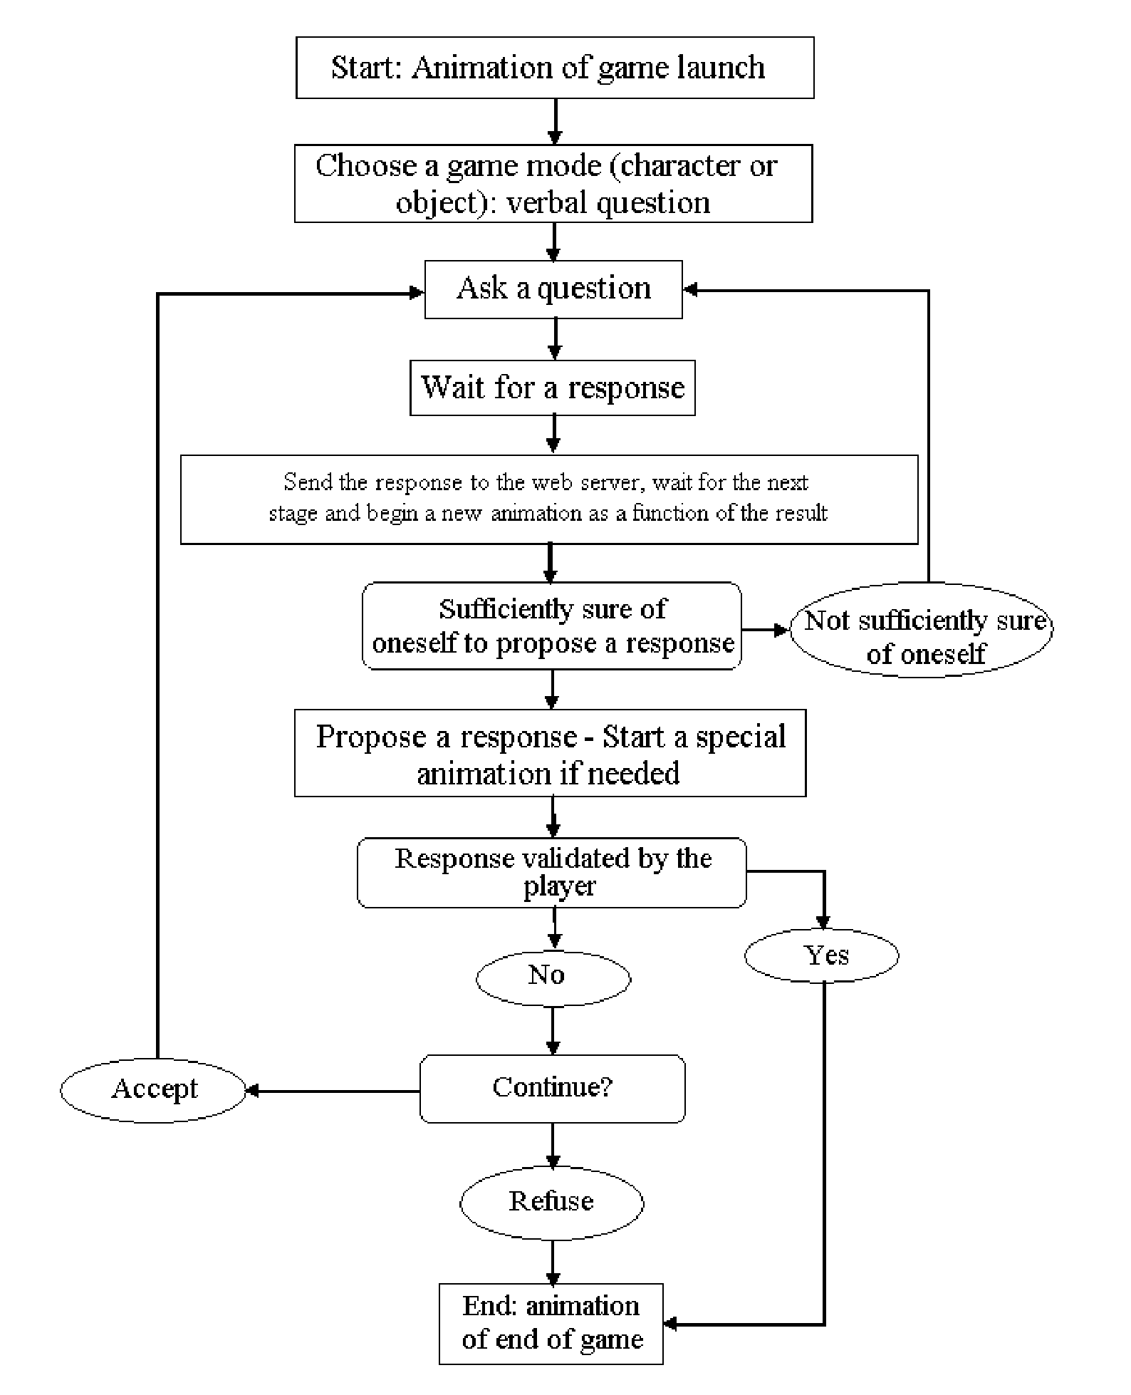

**3.2 Decomposition Description**

A decomposition of the subsystems in the architectural design is called a decomposition design.One may choose to give a functional description or an object oriented

description. For a functional description, put top level data flow diagram (DFD) and structural decomposition diagrams. For an OO description, subsystem model, object diagrams, generalization hierarchy diagram(s) , aggregation hierarchy diagram(s), interface specifications, and sequence diagrams here.

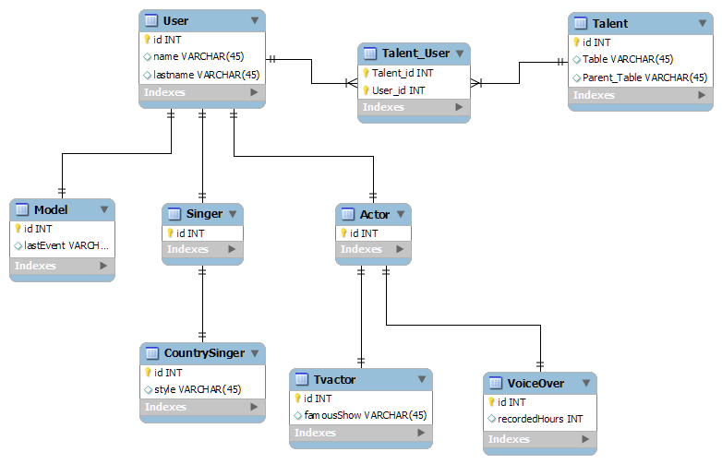

Fig2:DFD for who am i?

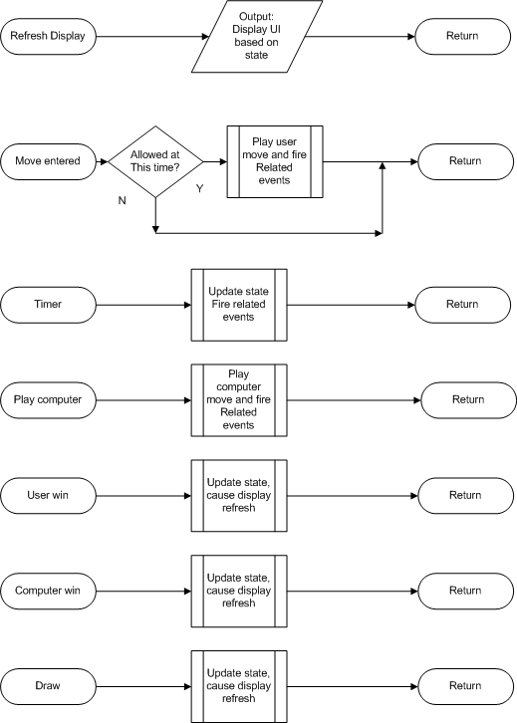

Fig 3:- Object diagram for tic-tac-toe

**3.3 Design Rationale**

A design rationale is the explicit listing of [decisions](http://en.wikipedia.org/wiki/Decision_making) made during a [design process](http://en.wikipedia.org/wiki/Design_process), and the reasons why those decisions were made. Its primary goal is to support [designers](http://en.wikipedia.org/wiki/Designer) by providing a means to [record](http://en.wikipedia.org/wiki/Document) and [communicate](http://en.wikipedia.org/wiki/Communicate) the argumentation and reasoning behind the design process. It should therefore include:

* the reasons behind a design decision,
* the justification for it,
* the other alternatives considered,
* the trade offs evaluated, and
* the argumentation that led to the decision.

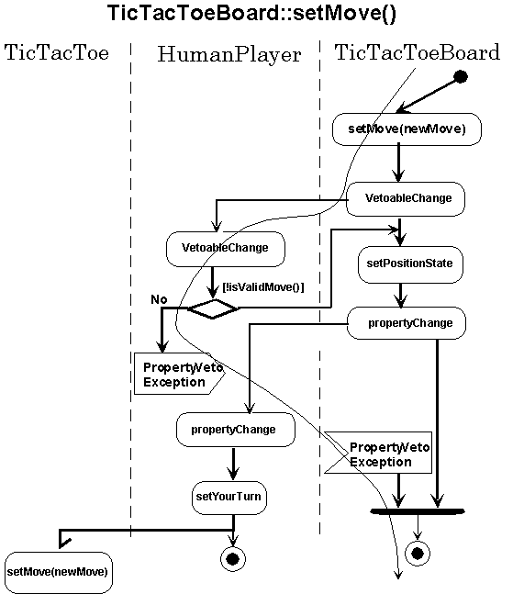

Fig 4:-Class diagram for tic- tac-toe.

**3.4 Design Issues**

The various issues faced by us while creating this game can be differentiated into functional and non functional issues.

The functional issues can be:-

1. The database is very large for it needs to store a lot amount of data for who am I and possible combinations for tic tac toe.

2. User screens should be attractive and interactive.

The non-functional issues could be listed as:-

1. Database should be protected and should have proper authentication code so that no one can breach into the system.

2. It should be available for 24/7 to the user.

3. Maintainability is another issue. The database needs to be updated every now and then.

**4. DATA DESIGN**

**4.1 Data Description**

The ER Diagram is a graphical tool used to describe and analyze the movement of data through the system-manual or automated-including the entities, the relations between different entities and the attributes of different relations or attributes are the central tool and the basis from which other components can be developed. While drawing the ER, the approach given by Yourdon has been followed. The symbol description is:-

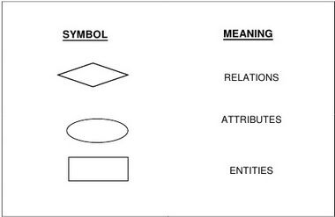.

Fig 5:- Symbols used in ER Diagram

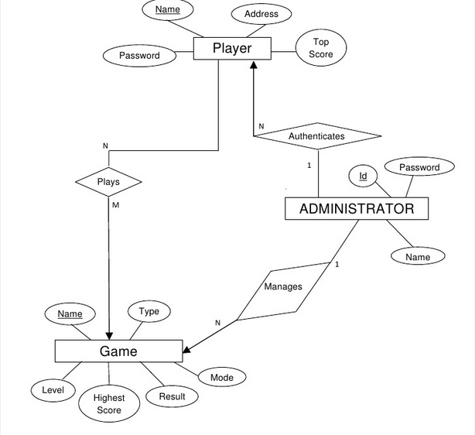

Fig 6 :-The ER DIAGRAM for both the games

**5.COMPONENT DESIGN**

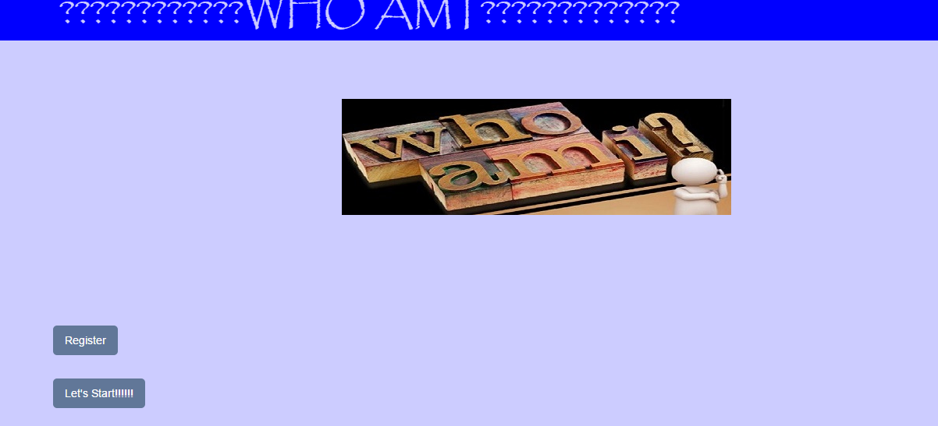

Fig 7:- Front page.

Fig 8 :-Registration page .

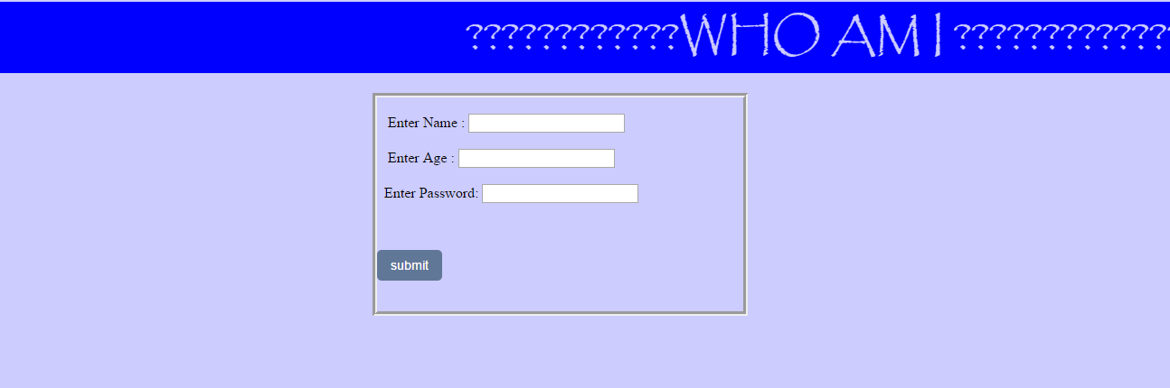

**6. HUMAN INTERFACE DESIGN**

**6.1 Overview of User Interface**

**Screen images**

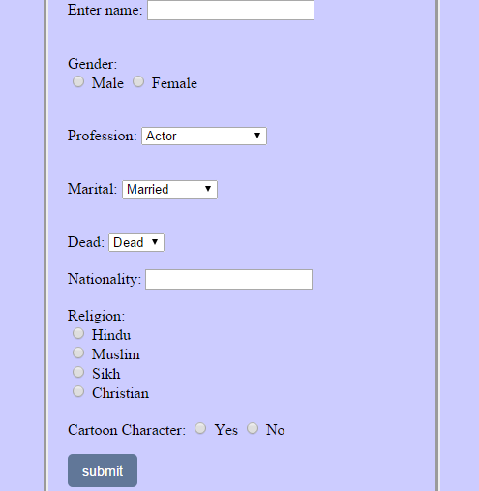

Fig 9:- To add a new Celebrity

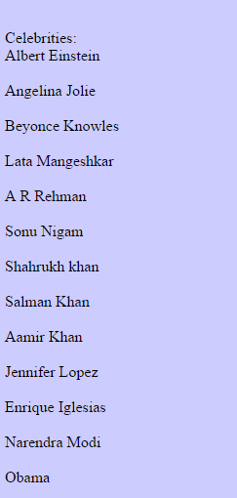

Fig 10:-The characters present in the game.

Fig :-11The questionnaire page .

